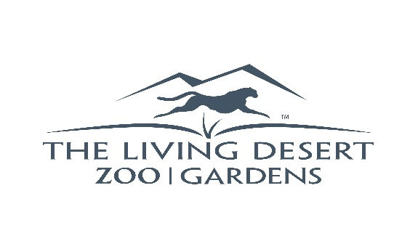
FOR IMMEDIATE RELEASE
Contact: Erin Scott
Sr, Marketing & Public Relations Manager
760-346-5694 x.2610
escott@livingdesert.org

THE LIVING DESERT ZOO AND GARDENS TO HOST ITS ANNUAL CONSERVATION-FOCUSED SPEAKER SERIES
Series is Free and Open to the Public
PALM DESERT/INDIAN WELLS, CA – (February 25, 2019) –The Living Desert Zoo and Gardens is hosting an enlightening speaker series focusing on its conservation efforts. The lectures, held in The Living Desert's Chase Administration Building, are free and open to the public. Space is limited to the first 100 people on a first-come, first-served basis.

“We invite the public to join us at these free, informative lectures and learn about some of our many conservation programs we support at The Living Desert,” said Dr. James Danoff-Burg, Director of Conservation at The Living Desert. “We are excited to present these experts who will share their knowledge and experience in a variety of subject matters related to our desert flora and fauna.”

Following is the schedule of speakers:

Monday, March 4, 2019; 12 p.m. – 1p.m.
(at Hoover Auditorium, Education Building)
Dr. Greg Rasmussen, Founder Executive Director, Painted Dog Trust
Painted Dog Research in Zimbabwe

Friday, March 8, 2019; 12 p.m. – 1 p.m.
Dr. Chris Tracy, Director Philip L Boyd Deep Canyon Research Center, UC Riverside Palm Desert
Sand Beneath Their Toes: Similarities and Differences in Ecology of the Coachella Fringe-Toed Lizard and the Desert Plated Lizard of Namibia

Friday, March 15, 2019; 12 p.m. - 1 p.m.
Dr. James Danoff-Burg, Director of Conservation, The Living Desert Zoo and Gardens
Forget That, I’m Going In Anyway: Why People Do and Don’t Support Trail Closures

Wednesday, March 20, 2019; 12 p.m. – 1p.m.
Dr. Laurie Marker, Founder and Executive Director, Cheetah Conservation Fund
Cheetah and Humans Sharing a Landscape

Wednesday, March 27,2019; 12 p.m. - 1p.m.
RoxAnna Breitigan, Director of Animal Care, The Living Desert Zoo and Gardens
Chad – A Conservation Adventure to Save a Species

Thursday, April 4, 2019; 12 p.m. – 1 p.m.
Felicia Sirchia, Fish & Wildlife Biologist, U.S. Fish and Wildlife Service
Conserving the Joshua Tree: The USFWS Species Status Assessment Approach

The Living Desert is open daily 9 a.m. to 5 p.m. For more information call (760) 346-5694 or visit www.LivingDesert.org.

About the Living Desert:
The Living Desert Zoo and Gardens is a nonprofit, accredited member of the Association of Zoos and Aquariums, ensuring the highest standards of all aspects of animal care, education, conservation, public service, and operations. The Zoo is active in conservation research, habitat protection, breeding programs and education initiatives around the world, as well as in its own community. The Zoo has been a top attraction in the Palm Springs area for nearly 50 years. The Living Desert is located at 47900 Portola Ave, Palm Desert, CA 92260. For more information: (760) 346-5694 or visit livingdesert.org.
###

