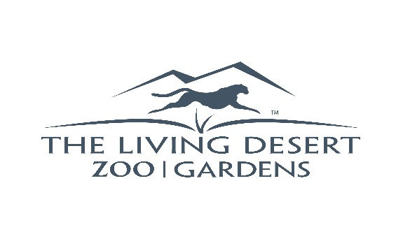
FOR IMMEDIATE RELEASE
Contact: Erin Scott
Sr Mgr, Marketing and PR
760-346-5694 x.2610
escott@livingdesert.org

JOIN TOGETHER TO CELEBRATE EARTH DAY AT
THE LIVING DESERT ZOO AND GARDENS

PALM DESERT/INDIAN WELLS, CA – (April 17, 2019) – Join together and help protect our planet at The Living Desert Zoo and Gardens’ Earth Day celebration, Monday, April 22, from 9 a.m. to noon. This year’s event includes morning yoga, a nature and pollinator walk, giveaways, and zero waste activities. Earth Day activities are free to members or with paid admission.

“With our mission focused on desert conservation through preservation, education and appreciation, we celebrate our incredible Earth every day here at The Living Desert,” said Allen Monroe, President/CEO of The Living Desert. “The official Earth Day serves as the perfect reminder to protect our most valuable natural resources, plants, and animals.”

Visitors can kick off Earth Day with yoga in the Palm Garden, led by friends from lululemon (bring your own mat), or enjoy a nature walk led by an expert volunteer and learn all about desert flora. The first 300 guests will receive a free milkweed plant which is attracts local butterflies; available while supplies last. In addition, the entire family will enjoy animal encounters, keeper chats and information about how to protect desert plants and animals, including the imperiled vaquita porpoise.

The Living Desert Zoo and Gardens is open daily from 9 a.m. to 5 p.m. For more information, visit LivingDesert.org or contact (760) 346-5694. The Living Desert’s free interactive app is available to download on smartphones and tablets.

About the Living Desert:
The Living Desert Zoo and Gardens is a nonprofit, accredited member of the Association of Zoos and Aquariums, ensuring the highest standards of all aspects of animal care, education, conservation, public service, and operations. The Zoo is active in conservation research, habitat protection, breeding programs and education initiatives around the world, as well as in its own community. The Zoo has been a top attraction in the Palm Springs area for nearly 50 years. The Living Desert is located at 47900 Portola Ave, Palm Desert, CA 92260. For more information: (760) 346-5694 or visit livingdesert.org.

